**Set up the python Environment**

You will learn how to install Python on Windows. After installing Python, we will run a simple program in idle Python editor and command prompt. Here is the steps to install python in your system.

**Step 1**

Click this link, it will take you to the Python official download website.

Website

[Download Python | Python.org](https://www.python.org/downloads/)

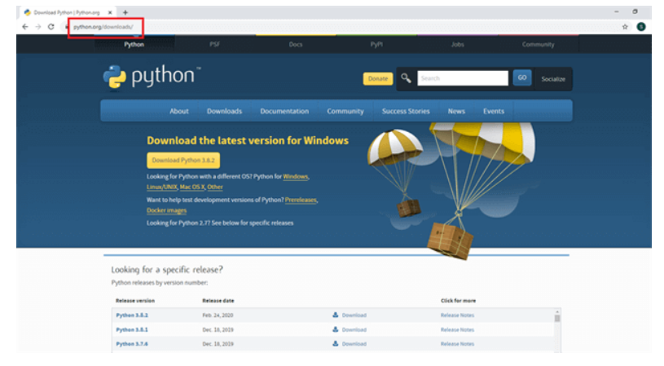

Image: Python official website download page

Source: python.org

**Step 2**

 Click the download button and you will see Python 3.8.2.

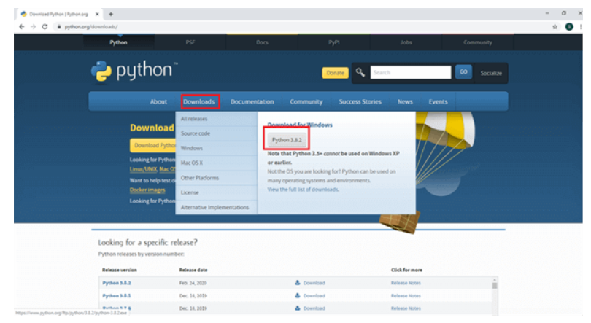

Image:  Downloading python

Source: python.org

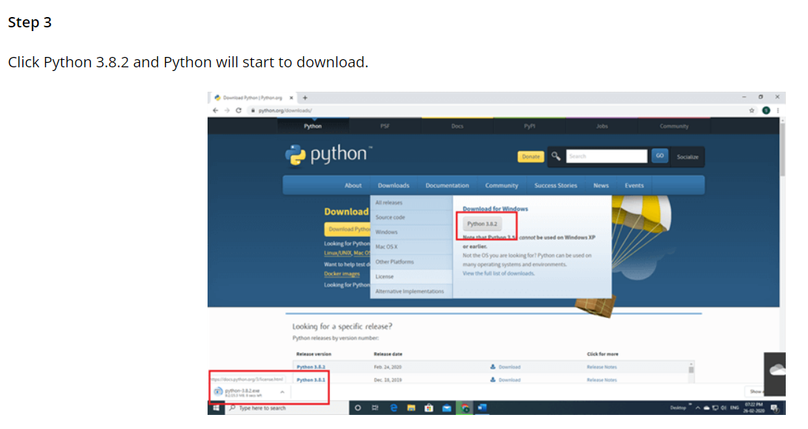

Image:  latest python

Source: python.org

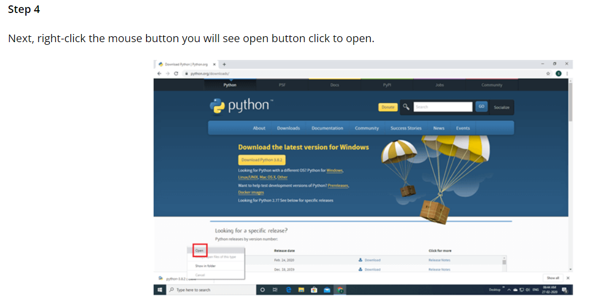

Image:  files for python installation

Source: python.org

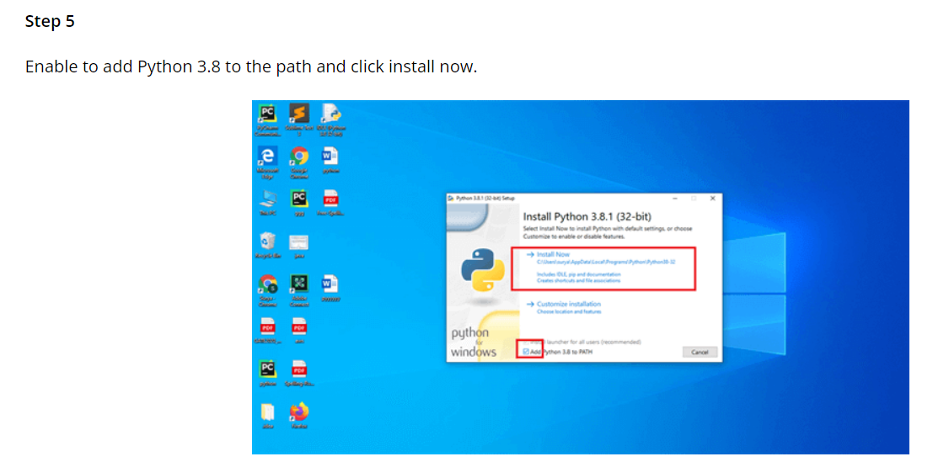

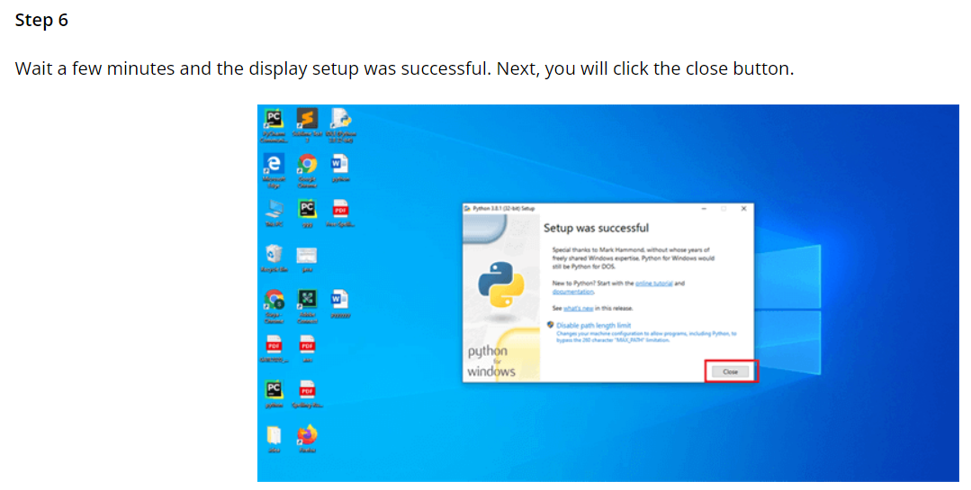  
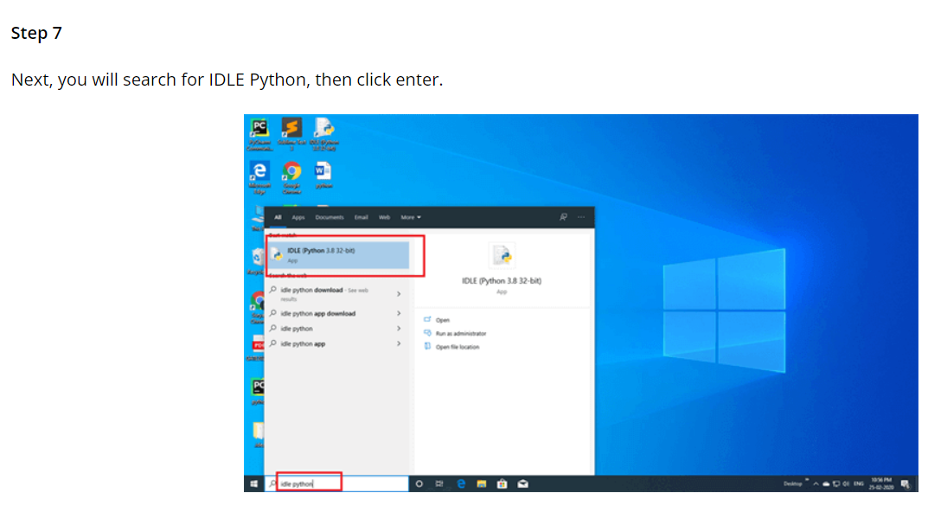  
**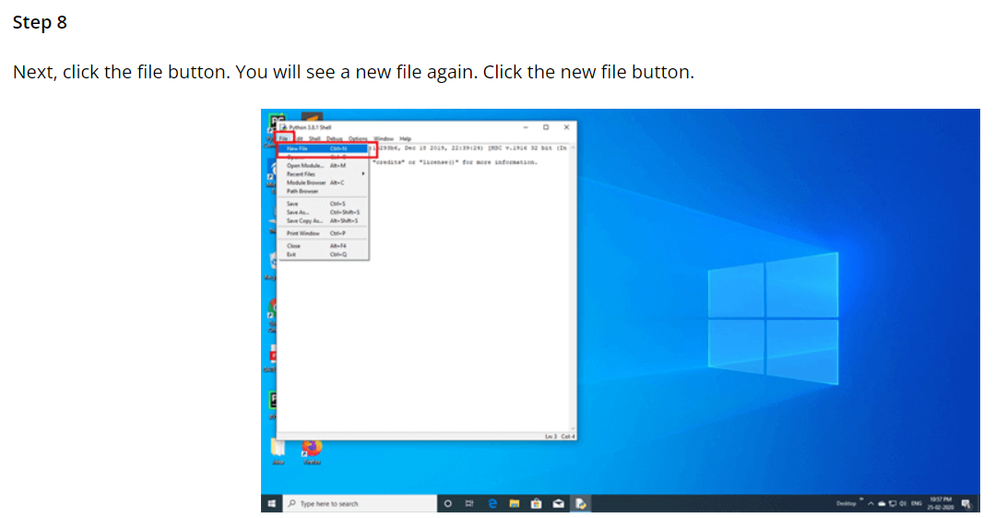  
Python Sample Program**

Now I am writing a program that displays "Welcome to Edunet Foundation"

Print is used to print the output statement.

**print** ("Welcome to Edunet Foundation")

Output

Welcome to Edunet Foundation

**Anaconda Installation and Setup**

Anaconda distribution is the most trusted Distribution for Data Science. Anaconda has more than 1500 open-source packages, an environment manager, and a Python/R data science distribution, as well as being free and easy to install on the latest operating systems. We will go with Anaconda 3 on Windows 10.

**Installation of Anaconda Navigator**

Let’s start with the installation process of Anaconda navigator on the Windows 10 Operating System.

**Step 1**

 Go to a web browser, Search this URL,

*https://www.anaconda.com/download/*

 Users can see this screen. Now, click the *Download* Button.

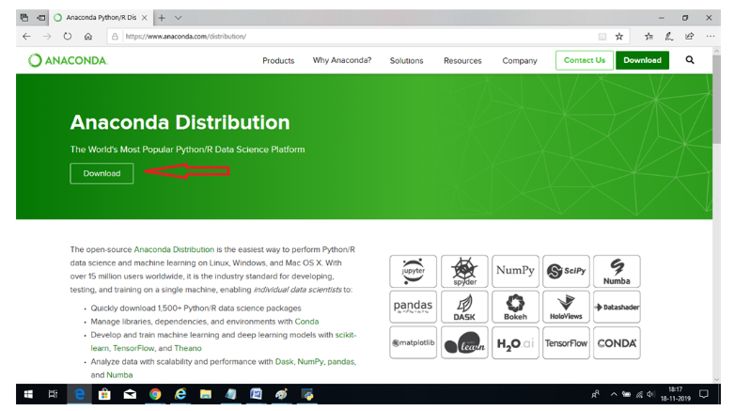

Image:  Anaconda website

Source: anaconda.org

**Step 2**

There are two options available on the screen choose either one of them,

*Download 64bit Anaconda editor*

or

*Download 32bit Anaconda editor*

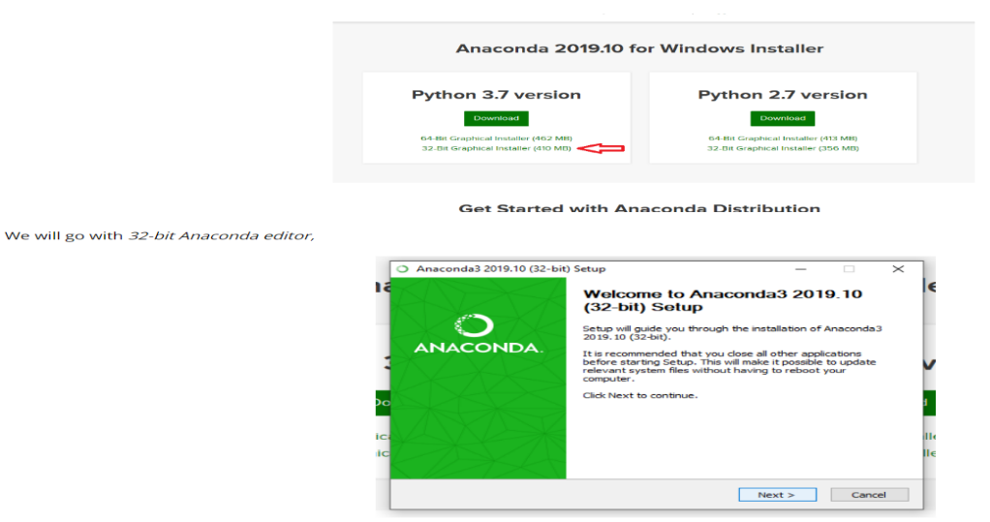

Image:  Downloading anaconda

Source: anaconda.org

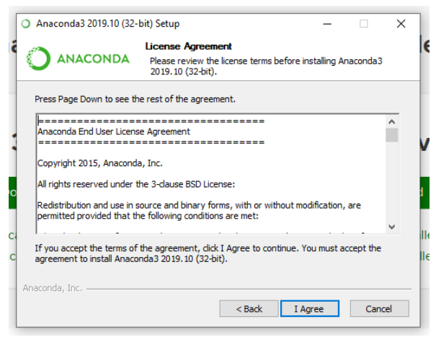

Image:  Anaconda installation

**Step 4**

For personal use or for a group of people, according to the requirements of the user, we have to decide the type of the installation,

As of now, we will install Anaconda Navigator for personal use, so choose this radio button: *Just Me(recommended)*

Select *Next*

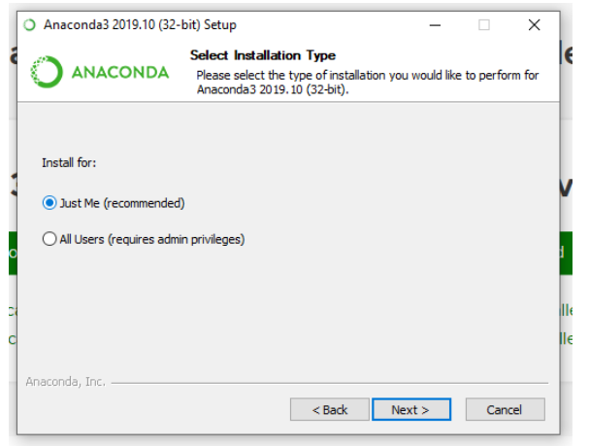

Image:  Installing anaconda (selecting users)

**Step 5**

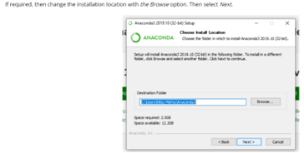

**Step 6**

Select both checkbox and click install.

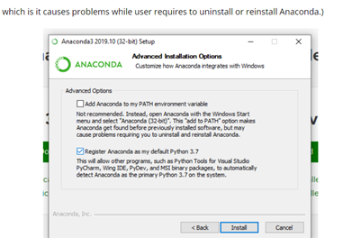

**Step 7**

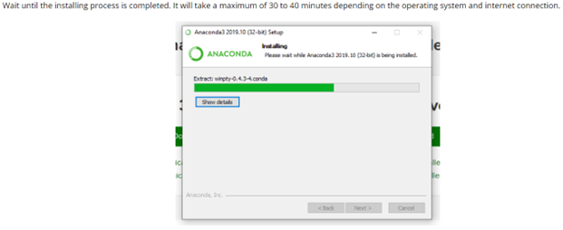

**Step 8**

Go to *Start* - Select *Anaconda Navigator (Anaconda3)*

 This is how Anaconda Navigator looks

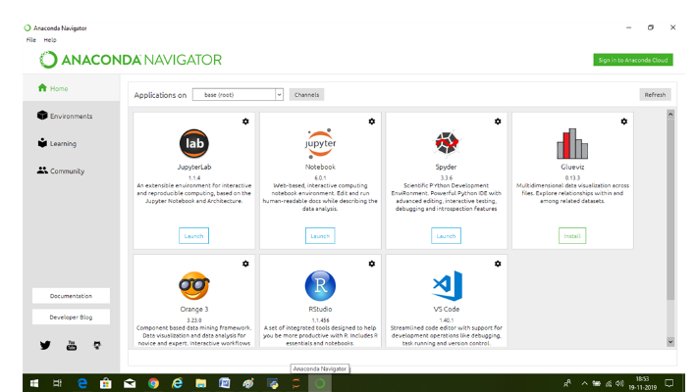

**Step 9**

*Launch* the *Jupyter Notebook*

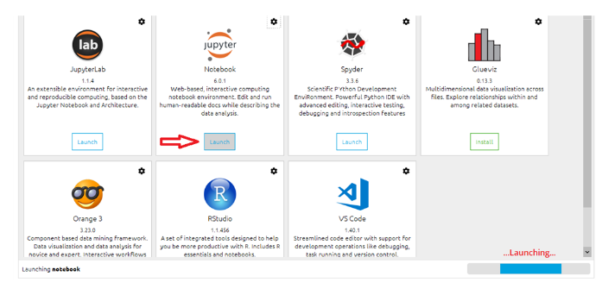

After a few minutes, you can check if it launched successfully and Jupyter Notebook is opened in a new window of the same browser.

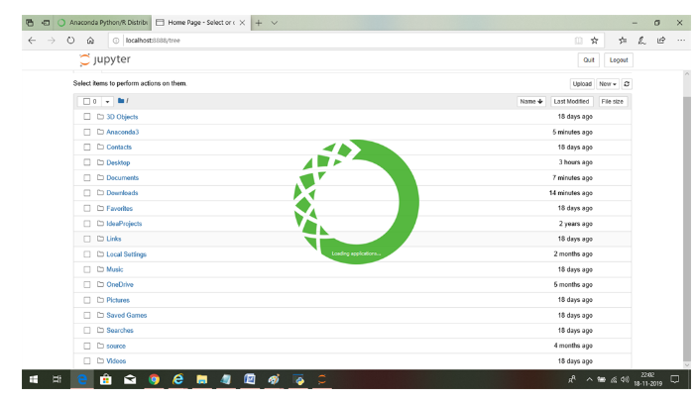

**Step 10**

All the Python Library and References are getting installed for the very first time. It will take a few minutes. Note that it runs on *http://localhost:8888/tree*

Choose *the New* dropdown menu and select *Python 3*.

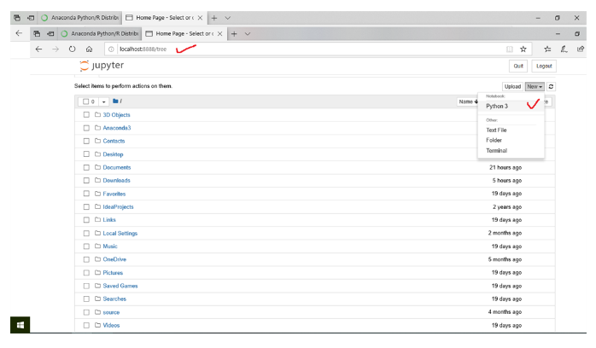

**Step 11**

This screen will be open where you can type code for the Python Applications.

